**Team Name**

Sh3rl0ck

**Team Members**

1. Punith Rajanna
2. Om Prakash Singh
3. Mehardeep Singh Sawhney
4. Shriram Tyagrajan

**Problem Statement**

Determine customer satisfaction and recommend offer with watsonx.ai - In this challenge, participants will use watsonx.ai to analyze customer feedback statements from a fictitious rental car company and offer relevant recommendations.

**Solution Approach**

1. First use pre-defined input data set (Train.csv and TestData.csv) to create initial model. The pre-defined Train Data only contained few questions and Recommendations based on primarily two columns “Customer_Service” and “Action”.
2. We enhanced the Train.csv by adding more feedbacks which included contexts like:
   1. Gender-based feedbacks (Female, Transgender)
   2. Marital Status (M,S)
   3. Children (0,1,2...)
3. We uploaded the updated Train.csv to the Notebook Assets and added reference to the file from Code Snippet -> train.csv -> pandas DataFrame
4. We added more Recommendations for different types of feedback and combined more than one recommendation to make recommendations more practical like:
   1. Vehicle Inspection, 10 percent off next ride
   2. Driver investigation, Voucher
   3. Driver Investigation, Assign female drivers in future
   4. 10 percent off next ride, Assign female drivers in future
   5. Vehicle Inspection, Full Refund
   6. Driver Investigation, 10 percent off next ride

Code Snippet to add custom file

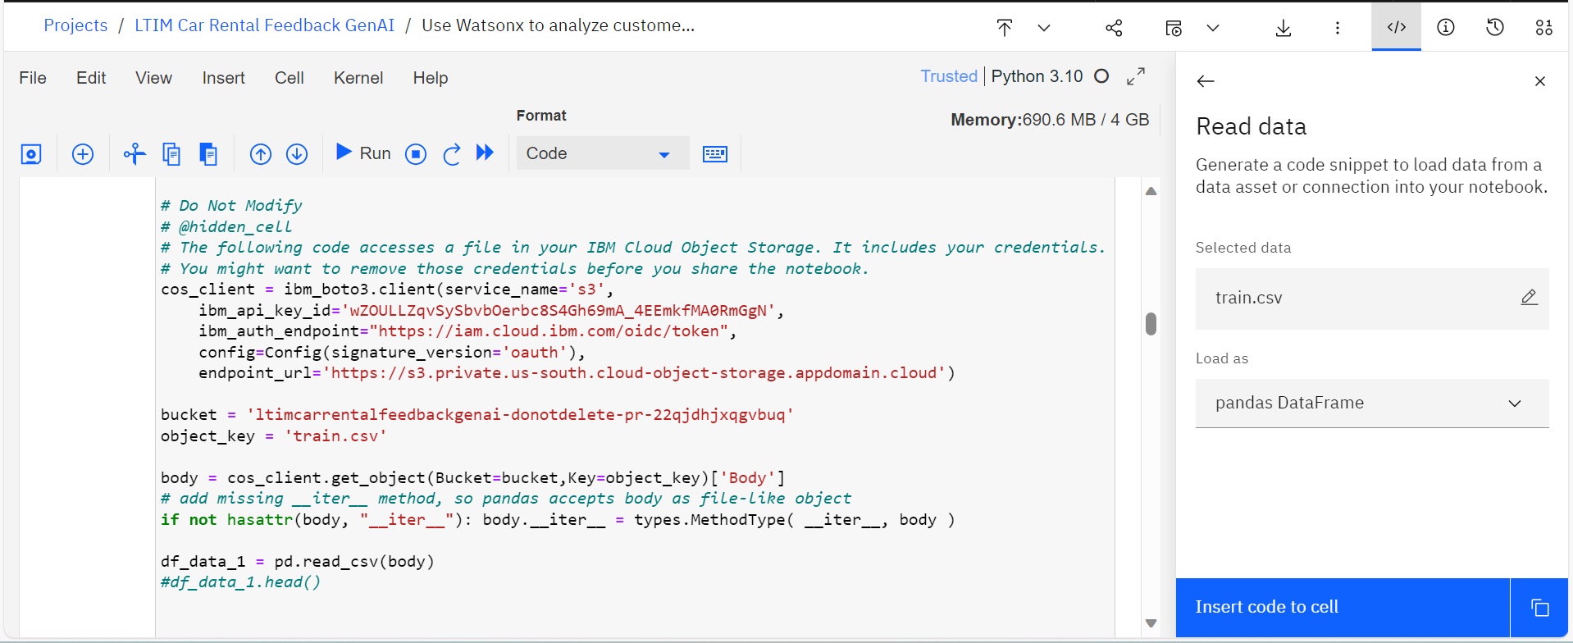

**Sample Feedbacks used for testing the model:**

* I experienced uncomfortable comments or advances from rental staff, which was completely unprofessional and inappropriate.
* The rental vehicle lacked essential safety features like a panic button or a designated emergency contact option, leaving me feeling vulnerable.
* In the event of a breakdown, there was no female mechanic or female-friendly resources available for assistance, which was unsettling.
* The drop-off location was in an isolated or poorly monitored area, causing concern for safety, especially when transgender travelers may feel more vulnerable.
* There was a lack of privacy when completing paperwork at the rental office, which is a concern for female travelers who may be traveling alone.

**Prompt Lab Inputs**

Generate next best offer to unsatisfied customer. Choose offer recommendation from the following list: 'On-demand pickup location', 'Free Upgrade', 'Voucher', 'Premium features', 'Vehicle Inspection, 10 percent off next ride', 'Driver investigation, Voucher', 'Driver Investigation, Assign female drivers in future', '10 percent off next ride, Assign female drivers in future', 'Vehicle Inspection, Full Refund', 'Driver Investigation, 10 percent off next ride'.

comment: <add your feedback>

offer recommended:

**Sample Screenshots**

Feedback: I was misgendered

Feedback: I do not understand why I have to pay additional fee if vehicle is returned without a full tank.

Feedback: Customer service was friendly and helpful.

Feedback: Customer service was friendly and helpful.

**Notebook Exported File**

